FreeNAS任务说明

1. 凌剑聪 第七周 内容说明

## 截图

成功添加后，会显示组的信息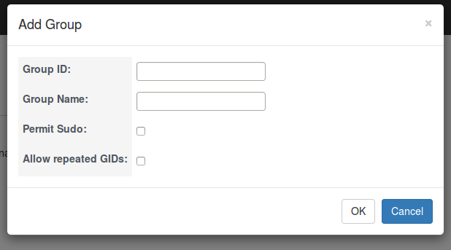

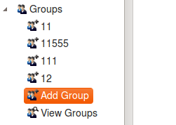

## 核心代码：

### Models:

**class** Groups(models.Model):

groupID=models.IntegerField()

groupName=models.CharField(max_length=50)

permitSudo=models.BooleanField(default=True)

allowedRepeat=models.BooleanField(default=True)

**def** __unicode__(self):

**return** str(self.groupID)+**'\t'**+str(self.groupName)+**'\t'**+str(self.permitSudo)+**'\t'**+str(self.allowedRepeat)

### HTML:(bootstrap框架)

*<!-- Modal -->*

<**div class="modal fade" id="lingjiancongModalAddGroup" tabindex="-1" role="dialog" aria-labelledby="myModalLabel" aria-hidden="true"**>

<**div class="modal-dialog"**>

<**div class="modal-content"**>

<**div class="modal-header"**>

<**button type="button" class="close" data-dismiss="modal" aria-label="Close"**><**span aria-hidden="true"**>**&times;**</**span**></**button**>

<**h4 class="modal-title" id="myModalLabel"**>Add Group</**h4**>

</**div**>

<**div class="modal-body"**>

<**form action="/addGroup/" method="get" id="formAddGroupPopover"**>

<**table id='addGroupPopover'** >

<**tbody**>

<**tr**>

<**th**><**label for="addGroupID"**>Group ID:</**label**></**th**>

<**td**><**div**><**input type="text" name="addGroupID" id="addGroupID"**/><**div id="addGroupIDCheck" style="display**:**none"**>The id already exits</**div**></**div**></**td**>

</**tr**>

<**tr**>

<**th**><**label for="addGroupName"**>Group Name:</**label**></**th**>

<**td**><**div**><**input type="text" name="addGroupName" id="addGroupName"**/></**div**><**div id="addGroupNameCheck" style="display**:**none"**>The name already exits</**div**></**td**>

</**tr**>

<**tr**>

<**th**><**label for="permitSudo"**>Permit Sudo:</**label**></**th**>

<**td**><**div**><**input type="checkbox" name="permitSudo" id="permitSudo"**/></**div**></**td**>

</**tr**>

<**tr**>

<**th**><**label for="allowRepeatedGIDs"**>Allow repeated GIDs:</**label**></**th**>

<**td**><**div**><**input type="checkbox" name="allowRepeatedGIDs" id="allowRepeatedGIDs"**/></**div**></**td**>

</**tbody**>

</**table**>

</**form**>

</**div**>

<**div class="modal-footer"**>

<**button type="button" class="btn btn-default" onclick="***addGroup*();**" id="buttonAddGroup"**>OK</**button**>

<**button type="button" class="btn btn-primary"**>Cancel</**button**>

</**div**>

</**div**>

</**div**>

</**div**>

*<!-- lingjiancong end -->*

### JS代码：

*/\*\**

*\* Created by ling on 15-4-17.*

*\*/*

**function** *addGroup*(){

**var** groupID=*$*(**"#addGroupID"**).val();

**var** GroupName=*$*(**"#addGroupName"**).val();

**var** permitSudo=*$*(**"#permitSudo"**).val();

**var** allowRepeatedGIDs=*$*(**"#allowRepeatedGIDs"**).val();

**url**=**"/ajax/checkAddGroup/?"**+**"groupID="**+groupID+**"&GroupName="**+GroupName+**"&permitSudo="**+permitSudo+**"&allowRepeatedGIDs="**+allowRepeatedGIDs;

*$*.get(**url**,**function**(data){

**if**(data==**"2"**) {

**document**.getElementById(**"addGroupIDCheck"**).**style**.**display** = **"none"**;

**document**.getElementById(**"addGroupNameCheck"**).**style**.**display** = **"none"**;

**document**.getElementById(**"addGroupIDCheck"**).**style**.**display** = **"block"**;

}

**if**(data==**"1"**) {

**document**.getElementById(**"addGroupIDCheck"**).**style**.**display**=**"none"**;

**document**.getElementById(**"addGroupNameCheck"**).**style**.**display**=**"none"**;

**document**.getElementById(**"addGroupNameCheck"**).**style**.**display**=**"block"**;

}

**if**(data==**'0'**){

*$*(**'#lingjiancongModalAddGroup'**).modal(**'hide'**);

*//alert("12");*

**window**.**location**.**href**=**"/home/"**;

}

});

*//alert(groupID+GroupName+permitSudo+allowRepeatedGIDs);*

*//document.getElementById('formAddGroupPopover').submit();*

}